FUND PERFORMANCE  NAV/CCQ (VND) 30/04/2023 7,333.60  Performance (%)  1 month 3 months 6 months YTD Since Contribution Date  FUEIP100 -1.28% -6.55% 1.45% 3.35% -26.66%  VN30 -2.07% -6.55% 2.39% 4.60% -26.40%  VNINDEX -1.46% -5.59% 2.06% 4.17% -19.89%  * Contribution Date is closing date for Capital contribution registration: 25/08/2021  VN100 INDEX VS. VNINDEX  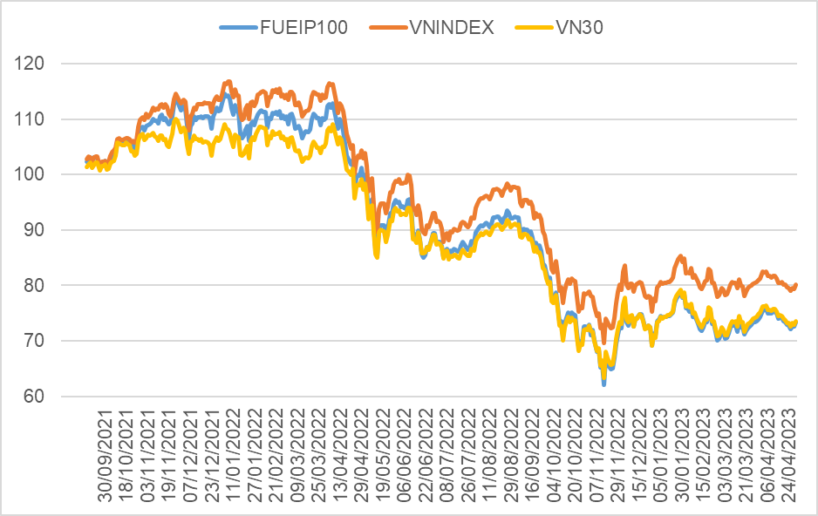  ETF ATTRIBUTES  FUEIP100 VN100  Number of stocks 70 100  Portfolio Valuation  P/E (x) 10.01 11.69  P/B (x) 1.48 1.46  ROE (%) 14.83% 13.36%  Tracking Error 0.55%  SECTOR ALLOCATION (% NAV) | QUICK FACTS  Fund name IPAAM VN100 ETF  Benchmark index VN100 Index  Ticker symbol FUEIP100  Inception 14/09/2021  Exchange HOSE  Fund Management Company I.P.A Securities Investment Fund Management Company (IPAAM)  Supervisory bank Vietcombank  Authorized Participants VNDirect, BSC  Fund total net assets VND 41,801,551,800  Outstanding Fund Units 5,700,000  INVESTMENT STRATEGY  IPAAM VN100 ETF applies a passive investment strategy, focus on replicating the return rate of the reference index.  The passive investment strategy expects long – term growth of Vietnam Stock market, maximizes profits by holding stocks, and minimizes daily stock trading.  HIGHLIGHTS OF VN100 INDEX  VN100 Index is a market index developed by HOSE, including 100 component stocks, with 30 stocks of VN30 Index and 70 stocks of VN MIDCAP Index.  - VN100 Index best represents the Vietnam Stock market, with coverage of nearly 90% of the market capitalization.  - High upside potential from medium – sized Company converting to Large Company.  MARKET CAPITALIZATION BREAKDOWN  Classify Proportion  Large Cap - VN30 74.0%  Medium Cap- VN MIDCAP 26.0%  TOP - 10 HOLDINGS  No. Ticker Company % NAV  1 VPB VPBank 6.5%  2 FPT FPT Corp 5.0%  3 ACB ACB Bank 4.8%  4 HPG Hoa Phat Group 4.8%  5 TCB Techcombank 4.7%  6 VIC VinGroup 4.1%  7 VNM VINAMILK 4.1%  8 VHM Vinhomes 3.7%  9 SSB Seabank 3.4%  10 STB Sacombank 3.3%  Total 44.4%

MARKET OVERVIEW
Vietnam’s economy Overview: Fiscal and monetary policy supportive amid weak economic data
- Weak economic activity was reflected in GSO data last week. The First, Index of Industrial Production (IIP) in the first 4 months of 2023 decreased by 1.8% y/y Amid weak global demand outlook. Vietnam's GDP increased by 3.3% in Q1/2023, growth decelerated due to the decline in exports and manufacturing. At the same time, the manufacturing PMI remained below the 50 no-change mark in April, dropping to 46.7 from 47.7, also reflecting the contraction of the manufacturing sector. Second, both exports and imports continue fell 17.1% y/y and 20.5% y/y in April 2023, volume and number of new order continue to decline as customer demand remains weak.
- On average, in the first 4 months of 2023, CPI increased by 3.84% over the same period last year; core inflation increased by 4.9%, higher than the general average CPI (up 3.84%).
- Fiscal and monetary policy is providing support amid weak economic data. On April 14, 2023, the Government issued Decree 12/2023/ND-CP on extending the deadline for payment of value added tax, corporate income tax, personal income tax and land rent in the year 2023. On April 23, 2023, The State Bank of Vietnam issued Circular No. 02/2023/TT-NHNN on restructuring the repayment term to support the financial system.
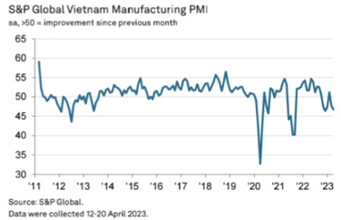
Stock market Overview: Series policies to support the economy is a positive signal for the stock market
- VN-INDEX dropped in April, closed at 1,049.12 points, a decrease of 1.46%. The market's recovery slowed down when (1) Foreign investors stopped net buying, (2) FED continued to raise interest rates by 25 basis points and (3) waited for the announcement of Q1 2023 earnings of listed companies.
- The average daily trading value of the market in April reached ~ VND 13,600 billion/session, up 29% compared to March .Market liquidity recovered well as investors' cash flow began to show signs of returning to the market in the context of cooling interest rates and a series of supportive policies for the corporate bond market and the real estate market.
- Vietnam’s Stock market is trading at 12.1x, as 0.7x of 5-year P/E average and TTM P/B is also trading at 0.7x of 5-year P/B average. This discount is gradually becoming attractive to prepare for a new growth cycle of the stock market.

VN-INDEX is trading 30% below its 5-year average valuation
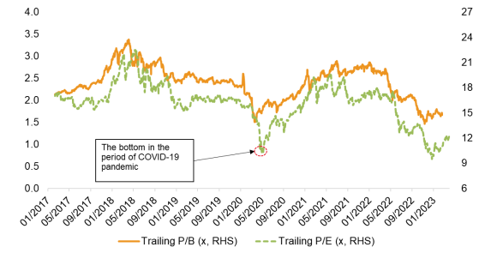
We think that the strategy of accumulating regularly and monthly for ETFs is a reasonable strategy so that investors can safely hold the same stock market, while taking advantage of the market's rising momentum in the medium-long term and taking advantage of the corrections to increase holdings.

DISCLAIMER
This report is prepared and pulished by I.P.A Securities Investment Fund Management Company (IPAAM). This report is only for reference purpose and could be changed without any notice. This report is not a prospectus, recommendation, or any guarantee of IPAAM. IPAAM has no responsibility to update, amend this report in any form if any issues relating to opinions, forecasting and estimations in this report change or become inaccurate. This report should not be used for accounting, tax purposes or making investment decisions. Investors should be highlighted that the performance results in the past do not ensure the Fund’s performance in the future. Value of a Fund Certificate and the Fund’s income can be increased or decreased and cannot be guaranteed by Asset Management Company. If Investors have concern about their investment decisions, Investor should obtain more information or consult experts in order to have right decisions.

